Air Mail
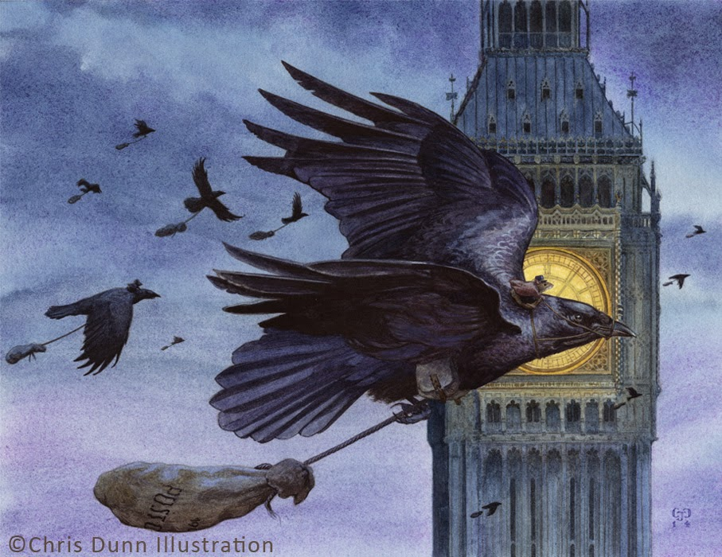
Credit: Chris Dunn

- Where is this?
- What are the birds doing?
- What is inside the bags?
- Why are there mice riding the birds?
- What time of day do you think it is? How do you know?

Persuasion: Write an Advert for a new postal service to rival all other services.

