Tuesday 22nd September

Please read this story with your child and discuss the questions on the following page.

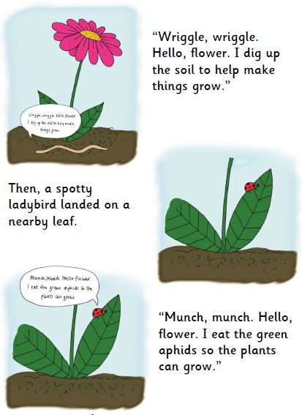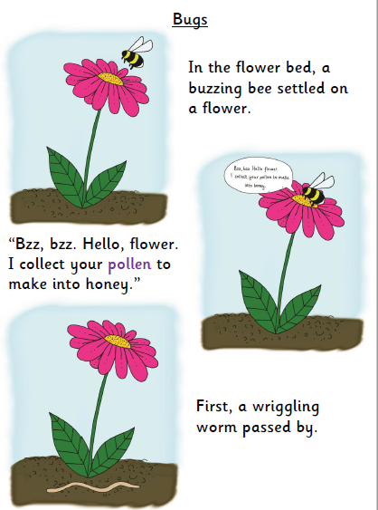

1

3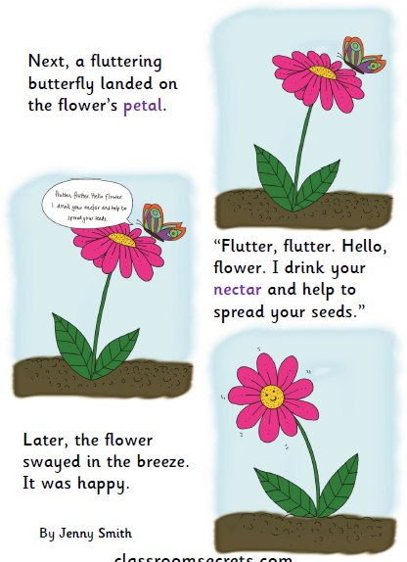

Discuss these questions with your child.

Where was the flower?

Name 3 of the bugs that passed by.

All the bugs have jobs. Somebody digs the garden. Who is it and why?

Why do you think the flower is happy?

Can you think of any other bugs or animals that might be helpful in the garden? Do you know of any garden pests?