Wednesday 22nd September
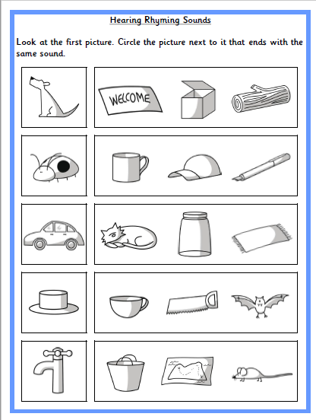
Can your child identify any other words that rhyme with the words?

